 | 26.9.1 Editors - Properties Editor - Modifiers Properties Tab - Mesh - Modify modifiers
Table of content
Detailed table of content 1
Mesh - Modify modifiers 5
Data Transfer 5
Mesh Cache 8
Mesh Sequence Cache 9
Normal Edit 12
Weighted Normal 13
UV Project 14
UV Warp 15
Vertex Weight Edit 16
Vertex Weight Mix 19
Vertex Weight Proximity 21

Detailed table of content
Detailed table of content
Detailed table of content 1
Mesh - Modify modifiers 5
Data Transfer 5
Usage 5
Source Object 5
Object transform 6
Mix Mode 6
Mix Factor 6
Vertex Group 6
Generate Data Layers 6
Vertex data 6
Vertex Groups / Bevel Weight 6
Mapping 6
Vertex Groups 6
Layer Selection 6
Layer Mapping 6
Edge Data 6
Sharp, UV Seam, etc. 7
Mapping 7
Face Corner Data 7
Custom normals, Vertex Colors, UV's 7
Mapping 7
Vertex Colors 7
Layer Selection 7
Layer Mapping 7
UV's 7
Layer Selection 7
Layer Mapping 7
Island Precision 7
Face Data 8
Smooth / Freestyle Mark 8
Mapping 8
Topology Mapping 8
Max Distance 8
Ray Radius 8
Mesh Cache 8
Format 8
File Path 8
Influence 8
Deform Mode 8
Interpolation 9
Vertex Group 9
Time Remapping 9
Frame / Time / Factor 9
Play Mode 9
Frame Start 9
Frame Scale 9
Axis Mapping 9
Forward/Up Axis 9
Flip Axis 9
Mesh Sequence Cache 9
Data property 10
Data browser 10
Name 10
Fake User 10
Open Cache File 10
Remove 10
File Path 10
Load File 10
Refresh Active 10
Object Path 10
Read Data 10
Vertex Interpolation 10
Time Subpanel 10
Sequence 11
Override Frame 11
Frame 11
Frame Offset 11
Render Procedural subpanel 11
Use Render Engine Procedural 11
Use Prefetch 11
Prefetch Cache Size 11
Velocity subpanel 11
Velocity Attribute 11
Velocity Unit 11
Velocity Scale 11
Normal Edit 12
Mode 12
Radial 12
Directional 12
Target 12
Parallel Normals 12
Mix 12
Mix Mode 12
Mix Factor 12
Vertex Group 13
Max Angle 13
Lock Polygon Normals 13
Offset 13
Weighted Normal 13
Weighting Mode 13
Face Area 13
Corner Angle 14
Face Area and Angle 14
Weight 14
Threshold 14
Keep Sharp 14
Face Influence 14
Vertex Group 14
Invert 14
UV Project 14
UV Map 15
Aspect X/Y and Scale X/Y 15
Projectors 15
Objects 15
UV Warp 15
Usage 15
UV Layer 15
UV Center 15
Axis U / V 16
Object From, To 16
Vertex Group 16
Invert 16
Transform 16
Offset 16
Scale 16
Rotation 16
Vertex Weight Edit 16
Vertex Group 17
Default Weight 17
Group Add 17
Threshold 17
Group Remove 17
Threshold 17
Normalize Weights 17
Falloff subpanel 17
Type 17
Linear 17
Custom Curve 17
Sharp, Smooth, Root and Sphere 17
Random 17
Median Step 17
Invert 18
Influence 18
Global Influence 18
Mask Vertex Group 18
Invert 18
Mask Texture 18
Texture Property 18
Texture Browser 18
Name 18
Fake User 18
New Texture 18
Remove 18
Show Texture in Texture Tab 18
Channel 18
Texture Coordinates 19
Vertex Weight Mix 19
Vertex Group A 19
Vertex Group B 19
Default Weight A 19
Default Weight B 19
Vertex Set 19
All 19
Vgroup A 19
Vgroup B 19
Vgroup A or B 20
Vgroup and B 20
Mix Mode 20
Replace weights 20
Add to weights 20
Subtract from weights 20
Multiply weights 20
Divide weights 20
Difference 20
Average 20
Influence 20
Global Influence 20
Mask Vertex Group 20
Invert 21
Mask Texture 21
Texture Property 21
Texture Browser 21
Name 21
Fake User 21
New Texture 21
Remove 21
Show Texture in Texture Tab 21
Channel 21
Texture Coordinates 21
Vertex Weight Proximity 21
Vertex Group 22
Target Object 22
Proximity mode 22
Object 22
Geometry 22
Lowest 22
Highest 22
Normalize Weights 22
Falloff 22
Type 22
Linear 22
Custom Curve 22
Sharp, Smooth, Root and Sphere 23
Random 23
Median Step 23
Invert 23
Influence 23
Global Influence 23
Mask Vertex Group 23
Invert 23
Mask Texture 23
Texture Property 23
Texture Browser 23
Name 23
Fake User 23
New Texture 23
Remove 24
Show Texture in Texture Tab 24
Channel 24
Texture Coordinates 24

Mesh - Modify modifiers

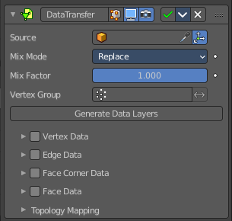
Data Transfer
The Data Transfer modifier transfers several types of data from one mesh to another. Data types include vertex groups, UV maps, vertex colors, custom normals…
Transfer works by generating a mapping between source mesh’s items (vertices, edges, etc.) and destination ones, either on a one-to-one basis, or mapping several source items to a single destination one, using interpolation.

Usage
Using this modifier will not create destination data layers. Use the Generate Data Layers button for this purpose when you are done with selecting the set of source data to transfer.
Creating those data layers on destination mesh is not part of the modifier stack. This means that they will remain. Even once the modifier is deleted, or if the source data selection is modified.

Source Object
Mesh object to copy the data from.

Object transform
Evaluate the source and destination objects in global space instead of local space.

Mix Mode
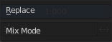
How to mix the destination elements with the source elements.

Mix Factor
How much of the transferred data gets mixed into existing one (not supported by all data types).

Vertex Group
Allows per-item fine control of the mix factor. Vertex group influence can be reverted using the small “arrow” button to the right.

Generate Data Layers
This modifier cannot generate needed data layers itself. Adjust the settings to your needs, then press this button to generate matching destination layers, if needed.

Vertex data
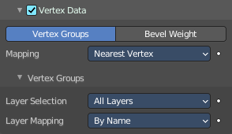
Activate this group when you want to transfer vertex data.

Vertex Groups / Bevel Weight
Which vertex data layers to transfer. Vertex groups or Bevel weight.

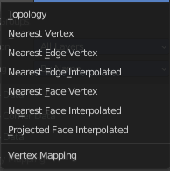
Mapping
The vertex mapping method to use.

Vertex Groups
Just active with data layer Vertex groups.

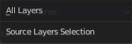
Layer Selection
What layer from the source object gets selected.

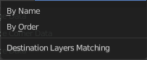
Layer Mapping
How to match the destination layer.

Edge Data
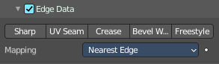
Activate this group when you want to transfer edge data.

Sharp, UV Seam, etc.
Which edge data layers to transfer. You can just use one method.

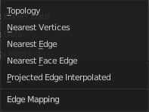
Mapping
The edge mapping method to use.

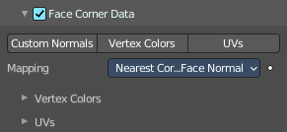
Face Corner Data

Custom normals, Vertex Colors, UV's
Which face corner data to transfer. You can just use one method.

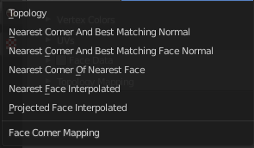
Mapping
The face corner data mapping method to use.

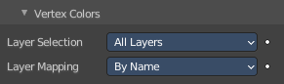
Vertex Colors
Further settings for when you choose Vertex colors.

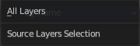
Layer Selection
Source Layer Selection.

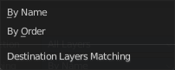
Layer Mapping
Destination layer mapping.

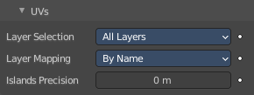
UV's
Further settings for when you choose UV's.

Layer Selection
Source Layer Selection.

Layer Mapping
Destination layer mapping.

Island Precision
The factor to control the island handling. A value of 0.0 means no island handling. A value of 0.02 is a good starting point.

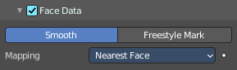
Face Data

Smooth / Freestyle Mark
Which poly data layers to transfer.

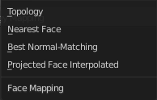
Mapping
The face mapping method.

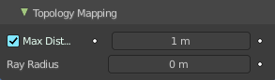
Topology Mapping

Max Distance
Only Neighbor Geometry. For non topology mapping, the source elements must be closer than the value in the edit box.

Ray Radius
The width of rays.

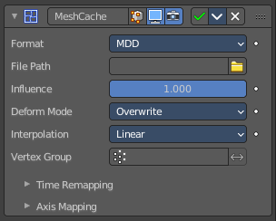
Mesh Cache
The Mesh Cache modifier allows you to apply animated mesh data to a mesh. And deform it when playing back.
This works in a similar way to shape keys. But uses external files, and allows to interchange between applications.
Tip! Both MDD and PC2 depend on the vertex order on the mesh remaining unchanged. This is a limitation of this method, so take care not to add/remove/reorder vertices once this modifier is used.

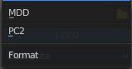
Format
The input file format (currently .mdd and .pc2 are supported).

File Path
Path to the cache file.

Influence
Factor to adjust the influence of the modifier’s deformation.

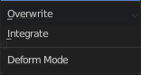
Deform Mode
This setting defaults to Overwrite which will replace the vertex locations with those in the cache file.
When you want to mix a mesh cache file with shape keys, then you can select the Deform option which integrates deformations with the mesh cache result.
Note that this feature is limited to making smaller, isolated edits and will not work for larger changes such as re-posing limbs.

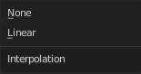
Interpolation
The blend mode between frames. Use linear when the frames in the cache file do not match up exactly with the frames in the blend-file.

Vertex Group
Which vertex group determines the influence of the modifier per point.

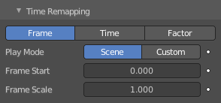
Time Remapping

Frame / Time / Factor
How time is calculated.

Play Mode
How playback operates.

Frame Start
Play the cache starting from this frame.

Frame Scale
Scale time by this factor (applied after the start value).

Axis Mapping

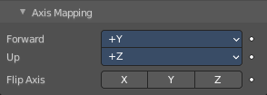
Forward/Up Axis
The axis for forward and up used in the source file.

Flip Axis
Allows you to flip the coordinates on an axis.

Mesh Sequence Cache
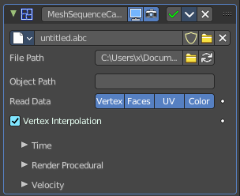
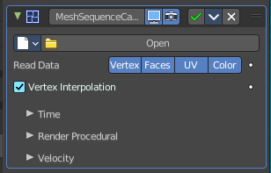
The Mesh Sequence Cache modifier loads data from Alembic files. It supports static meshes, but is mostly used to load animated meshes. Despite its name, this modifier also supports curves. It also handles file sequences, as well as meshes and curves with varying topology (like the result of fluid simulations).
When importing an Alembic file, Mesh Sequence Cache modifiers are automatically added to time-varying meshes. For time-varying object transforms (so animation of rotation, location, or scale), the Transform Cache Constraint is used.

Data property

Data browser
List of available Alembic files.

Name
The name of the current active alembic file.

Fake User
Keep this file in the scene even when it has no user anymore.

Open Cache File
Open an alembic file.

Remove
Remove the alembic file.

File Path
Path to the Alembic file.

Load File
Open an alembic file.

Refresh Active
Update the files and paths.

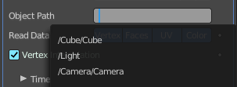
Object Path
Path to the object in the alembic file used to lookup geometric data.

Read Data
Type of data to read for a mesh object. Vertices, polygons, UV maps and Vertex Color layers.

Vertex Interpolation
Allow interpolation of vertex positions.

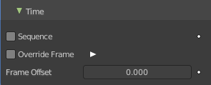
Time Subpanel

Sequence
Whether or not the cache is separated in a series of files.

Override Frame
Whether to use a custom frame for looking up data in the cache file, instead of using the current scene frame.

Frame
The time to use for looking up the data in the cache file, or to determine which to use in a file sequence.

Frame Offset
Define a frame offset to the current frame.

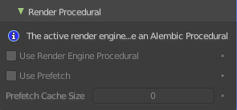
Render Procedural subpanel

Use Render Engine Procedural
This feature is just available for Cycles, and just in an experimental state.
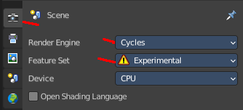
Display boxes as placeholders in the viewport.

Use Prefetch
This feature is just available for Cycles, and just in an experimental state.
When enabled, the Cycles procedural will preload animation data for faster update.

Prefetch Cache Size
This feature is just available for Cycles, and just in an experimental state.
Memory usage limit for the cache. If the data size does not fit the renderer is aborted. 0 disables the feature.

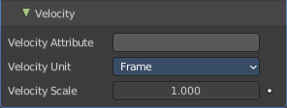
Velocity subpanel

Velocity Attribute
Name of the Alembic Attribute used for generating motion blur data.

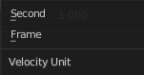
Velocity Unit
Define if velocity vectors are interpreted in Frame or Second.

Velocity Scale
Multiplier used to control the magnitude of the velocity for time effects.

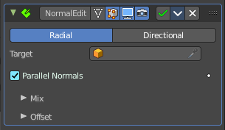
Normal Edit
The Normal Edit modifier affects (or generates) custom normals. It uses a few simple parametric methods to compute them, and mixes back those generated normals with existing ones.

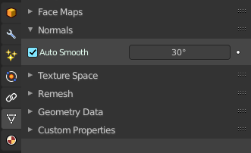
Note! This modifier requires custom normals to be enabled, which can be done by enabling Auto Smooth in the Properties.
Tip. More complex normal manipulations can be achieved by copying normals from one mesh to another, see the Data Transfer Modifier. Some shading effects can also make use of the Weighted Normals modifier.

Mode

Radial
Aligns normals with the (origin, vertex_coordinates) vector, in other words all normals seems to radiate from the given center point, as if they were emitted from an ellipsoid surface.

Directional
Makes all normals point (converge) towards a given target object.

Target
Uses this object’s origin as reference point when generating normals. A Target object is optional in Radial mode, but mandatory in Directional mode.

Parallel Normals
Only relevant in Directional mode. Makes all normals parallel to the line between both objects’ origins, instead of converging towards target’s origin.

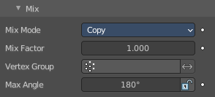
Mix

Mix Mode
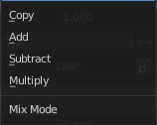
How to affect existing normals with newly generated ones.
Note that the Multiply option is not a cross product, but a mere component-by-component multiplication.

Mix Factor
How much of the generated normals get mixed into existing ones.

Vertex Group
Allows per-item fine control of the mix factor. The vertex group influence can be reverted by using the small “arrow” button to the right.

Max Angle
Forbids new generated normals to have an angle to the original normal above that given threshold. This is useful to prevent extreme changes, that can even lead to inverting the front/back sides of a face, and consequently to ugly shading artifacts.

Lock Polygon Normals
Prevents flipping (reversing front/back sides) of polygons which normal does not match anymore the side to which point its corners’ custom normals. Can also help avoiding shading issues.

Offset
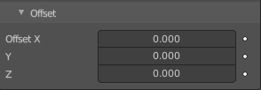
Gives the origin of the modified object an offset before using it to generate normals.
Offset is only relevant in Radial mode if no Target Object is set, and in Directional mode when Parallel Normals is set.

Weighted Normal
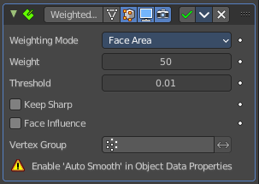
This modifier allows you to change the custom normals of a mesh. This can be useful to make some faces appear very flat during shading, among other effects.

Note! This modifier requires custom normals to be enabled, which can be done by enabling Auto Smooth in the Properties.

Weighting Mode
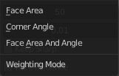
The normals around a vertex will be combined to create a custom (per face corner) normal using various weights for each. The Weighting Mode defines how to compute the weights.

Face Area
Weight according to the area of the face that the normal originates. A larger area means that the normal from that face will get a higher weight in final result.

Corner Angle
Weight according to the angle each face forms at the vertex.

Face Area and Angle
Weights are obtained by multiplying the face area and corner angle ones.

Weight
Determines how strongly the weights are biased according to the face areas and/or corner angles, a bit like a contrast setting for a picture.
A value of 50 means all faces are weighted uniformly.
More than 50 means faces with higher area or angles are given even more weight (more “contrast”).
Less than 50 means faces with higher area or angles are given lesser weights (less “contrast”).

Threshold
A weight-rounding threshold which means that, if two angles or areas differ by less than that threshold, they will get equal weights.

Keep Sharp
Preserve sharp edges, though smoothing will still happen if there are multiple faces between any two sharp edges.

Face Influence
Use face weights as assigned by the Set Strength tool or by the Set Strength mode of a Bevel modifier.
For example, if three faces meet at a vertex and have the face weights weak, medium, and strong, then only the normal associated with the strong face will be used to set the final result.

Vertex Group
If a vertex group is specified, the modifier will only affect those vertices.

Invert
Invert the selection (only affect the vertices not in the vertex group).

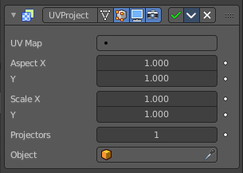
UV Project
The UV Project modifier acts like a slide projector. It emits a UV map from the negative Z axis of a controller object (such as an empty object), and applies it to the object as the “light” hits it.
UV Project is great for making spotlights more diverse, and also for creating decals to break up repetition.
Usually, an Image Texture node mapped to the UV map that the modifier targets is added to the object’s material.

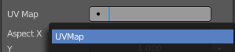
UV Map
Which UV map to modify. Defaults to the active rendering layer.

Aspect X/Y and Scale X/Y
Aspect and scale manipulation of the image. Only apply when a camera is used as projector object.

Projectors
Up to ten projector objects are supported. Each face will choose the closest and aligned projector with its surface normal. Projections emit from the negative Z axis (i.e. straight down a camera or light). If the projector is a camera, the projection will adhere to its perspective/orthographic setting.

Objects
Specify the projector object(s).

UV Warp
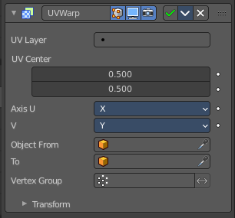
The UV Warp modifier transforms an object’s UV map based on values or two objects. Its purpose is to give you direct control over the object’s UV's in the 3D Viewport, allowing you to directly move, rotate, and scale existing UV coordinates using defined values or a controller object or bone.

Usage
How the UV's are warped is determined by the difference between the transforms (location, rotation and scale) of the from and to objects.
If the to object has the same transforms as the from object, the UV's will not be changed.
Assuming the UV Axis of the modifier is X/Y and the scale of the objects is (1, 1, 1), if the to object is one unit away from the from object on the X axis, the UV's will be transformed on the U axis (horizontally) by one full UV space (the entire width of the image).

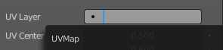
UV Layer
Which UV map to modify. Defaults to the active rendering layer.

UV Center
The center point of the UV map to use when applying scale or rotation. With (0, 0) at the bottom left and (1, 1) at the top right.

Axis U / V
The axes to use when mapping the 3D coordinates into 2D.

Object From, To
The two objects used to define the transformation.

Vertex Group
The vertex group can be used to scale the influence of the transformation per vertex.

Invert
Invert the selection (only affect the vertices not in the vertex group).

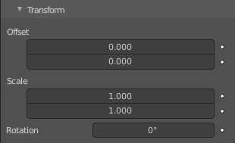
Transform

Offset
2D Offset for the warp.

Scale
2D Scale for the warp.

Rotation
2D Rotation for the warp.

Vertex Weight Edit
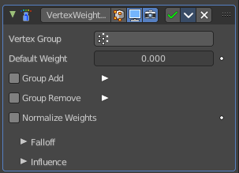
This modifier is intended to edit the weights of a vertex group.
The general process is the following, for each vertex:
(Optional) It does the mapping, either through one of the predefined functions, or a custom mapping curve.

It applies the influence factor, and optionally the vertex group or texture mask (0.0 means original weight, 1.0 means fully mapped weight).
It applies back the weight to the vertex, and/or it might optionally remove the vertex from the group if its weight is below a given threshold, or add it if it is above a given threshold.
Important! This modifier does implicit clamping of weight values in the standard (0.0 to 1.0) range. All values below 0.0 will be set to 0.0, and all values above 1.0 will be set to 1.0.
Note! You can view the modified weights in Weight Paint Mode. This also implies that you will have to disable the Vertex Weight Edit modifier if you want to see the original weights of the vertex group you are editing.

Vertex Group
The vertex group to affect.

Default Weight
The default weight to assign to all vertices not in the given vertex group.

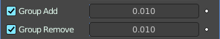
Group Add
Adds vertices with a final weight over Add Threshold to the vertex group.

Threshold
The add threshold.

Group Remove
Removes vertices with a final weight below Remove Threshold from the vertex group.

Threshold
The remove threshold.

Normalize Weights
Normalize the resulting weights. Without normalizing the values are clamped between 0 and 1.

Falloff subpanel
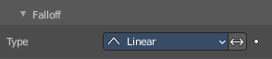

Type
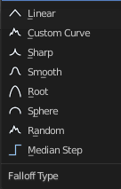
How weights are mapped to their new values.

Linear
No mapping.

Custom Curve
Allows the user to manually define the mapping using a curve.

Sharp, Smooth, Root and Sphere
These are classical mapping functions, from spikiest to roundest.

Random
Uses a random value for each vertex.

Median Step
Creates binary weights (0.0 or 1.0), with 0.5 as cutting value.

Invert
Inverts the falloff.

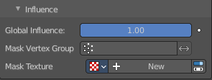
Influence

Global Influence
The overall influence of the modifier (0.0 will leave the vertex group’s weights untouched, 1.0 is standard influence).
Important! Influence only affects weights, adding/removing of vertices to/from vertex group is not prevented by setting this value to 0.0. In addition, a per-vertex fine control of the effect is possible using either a vertex group or a texture (both are mutually exclusive). The per-vertex values from those will be multiplied with the Global Influence.

Mask Vertex Group
Choose a vertex group for masking.

Invert
Invert vertex group mask influence.

Mask Texture
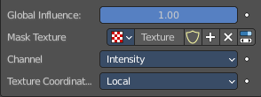
Choose a texture for masking. Note that using a mask texture will remove the mask vertex group.

Texture Property

Texture Browser
A list of the available textures in the scene.

Name
The name of the currently active texture. You can rename the texture here by clicking at the edit box.

Fake User
Keep this texture in the scene even if it has no user.

New Texture
Add a new texture.

Remove
Remove the texture.

Show Texture in Texture Tab
Jumps to the texture tab where you can edit your texture.

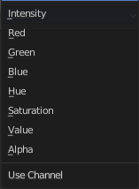
Channel
Which channel of the texture to use for masking.

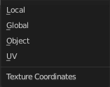
Texture Coordinates
Which texture coordinates of the texture to use for masking.

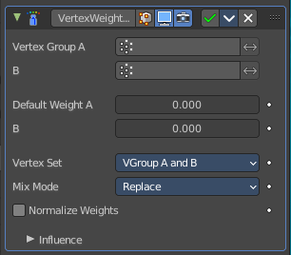
Vertex Weight Mix
Vertex Weight Mix Modifier
This modifier mixes a second vertex group (or a simple value) into the affected vertex group, using different operations.
Important! This modifier does implicit clamping of weight values in the standard (0.0 to 1.0) range. All values below 0.0 will be set to 0.0, and all values above 1.0 will be set to 1.0.
Note! You can view the modified weights in Weight Paint Mode. This also implies that you will have to disable the Vertex Weight Mix modifier if you want to see the original weights of the vertex group you are editing.

Vertex Group A
The vertex group to affect.

Vertex Group B
The second vertex group to mix into the affected one. Leave it empty if you only want to mix in a simple value.

Default Weight A
The default weight to assign to all vertices not in the given vertex group.

Default Weight B
The default weight to assign to all vertices not in the given second vertex group.

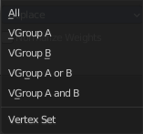
Vertex Set
Which vertices should be affected.
Important! When using All vertices, Vertices from group B or Vertices from one group, vertices might be added to the affected vertex group.

All
Affects all vertices, disregarding the vertex groups content.

Vgroup A
Affects only vertices belonging to the affected vertex group.

Vgroup B
Affects only vertices belonging to the second vertex group.

Vgroup A or B
Affects only vertices belonging to at least one of the vertex groups.

Vgroup and B
Affects only vertices belonging to both vertex groups.

Mix Mode
How the vertex group weights are affected by the other vertex group’s weights.

Replace weights
Replaces affected weights with the second group’s weights.

Add to weights
Adds the values of Group B to Group A.

Subtract from weights
Subtracts the values of Group B from Group A.

Multiply weights
Multiplies the values of Group B with Group A.

Divide weights
Divides the values of Group A by Group B.

Difference
Subtracts the smaller of the two values from the larger.

Average
Adds the values together, then divides by 2.

Influence

Global Influence
The overall influence of the modifier (0.0 will leave the vertex group’s weights untouched, 1.0 is standard influence).
Important! Influence only affects weights, adding/removing of vertices to/from vertex group is not prevented by setting this value to 0.0. In addition, a per-vertex fine control of the effect is possible using either a vertex group or a texture (both are mutually exclusive). The per-vertex values from those will be multiplied with the Global Influence.

Mask Vertex Group
Choose a vertex group for masking.

Invert
Invert vertex group mask influence.

Mask Texture
Choose a texture for masking. Note that using a mask texture will remove the mask vertex group.

Texture Property

Texture Browser
A list of the available textures in the scene.

Name
The name of the currently active texture. You can rename the texture here by clicking at the edit box.

Fake User
Keep this texture in the scene even if it has no user.

New Texture
Add a new texture.

Remove
Remove the texture.

Show Texture in Texture Tab
Jumps to the texture tab where you can edit your texture.

Channel
Which channel of the texture to use for masking.

Texture Coordinates
Which texture coordinates of the texture to use for masking.

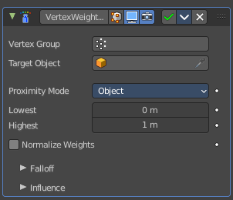
Vertex Weight Proximity
This modifier sets the weights of the given vertex group, based on the distance between the object (or its vertices), and another target object (or its geometry).
Warning1 This modifier does implicit clamping of weight values in the standard (0.0 to 1.0) range. All values below 0.0 will be set to 0.0, and all values above 1.0 will be set to 1.0.
Note! You can view the modified weights in Weight Paint Mode. This also implies that you will have to disable the Vertex Weight Proximity modifier if you want to see the original weights of the vertex group you are editing.

Vertex Group
The vertex group to affect.

Target Object
The object from which to compute distances.

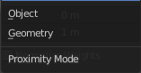
Proximity mode

Object
Use the distance between the modified mesh object and the target object as weight for all vertices in the affected vertex group.

Geometry
Use the distance between each vertex and the target object, or its geometry.
Note! If you enable more than one of them, the shortest distance will be used. If the target object has no geometry (e.g. an empty or camera), it will use the location of the object itself.

Lowest
Distance mapping to 0.0 weight. Tip! Lowest can be set above Highest to reverse the mapping.

Highest
Distance mapping to 1.0 weight.

Normalize Weights
Normalize the resulting weights. Without this option they get only clamped within the 0.0 - 1.0 range.

Falloff

Type
How weights are mapped to their new values.

Linear
No mapping.

Custom Curve
Allows the user to manually define the mapping using a curve.

Sharp, Smooth, Root and Sphere
These are classical mapping functions, from spikiest to roundest.

Random
Uses a random value for each vertex.

Median Step
Creates binary weights (0.0 or 1.0), with 0.5 as cutting value.

Invert
Inverts the falloff.

Influence

Global Influence
The overall influence of the modifier (0.0 will leave the vertex group’s weights untouched, 1.0 is standard influence).
Important! Influence only affects weights, adding/removing of vertices to/from vertex group is not prevented by setting this value to 0.0. In addition, a per-vertex fine control of the effect is possible using either a vertex group or a texture (both are mutually exclusive). The per-vertex values from those will be multiplied with the Global Influence.

Mask Vertex Group
Choose a vertex group for masking.

Invert
Invert vertex group mask influence.

Mask Texture
Choose a texture for masking. Note that using a mask texture will remove the mask vertex group.

Texture Property

Texture Browser
A list of the available textures in the scene.

Name
The name of the currently active texture. You can rename the texture here by clicking at the edit box.

Fake User
Keep this texture in the scene even if it has no user.

New Texture
Add a new texture.

Remove
Remove the texture.

Show Texture in Texture Tab
Jumps to the texture tab where you can edit your texture.

Channel
Which channel of the texture to use for masking.

Texture Coordinates
Which texture coordinates of the texture to use for masking.

